Tasmanian Government Tenders

Business user manual
July 2026 | Version 13

Contents
Introduction 2
Some tips about using our site 2
Registration 3
New registration 3
Logging in 6
Forgotten your password? 7
Forgotten your username? 8
Update your registration 8
Removing your registration 9
Downloadable procurement documentation 9
Electronic lodgement of submission 10
Important information 10
Document requirements 10
File Naming Conventions 11
Accepted File Types 11
File Size Limits 11
Alternative offer 11
Estimated time for electronic submission 11
How to electronically lodge your Submission 12
Conditions of use 12
Current time 13
Submission confirmation 14
Incomplete submission 14
Amending or adding files 15
How to submit a response to a selective tender (Multi-Stage procurements) 15
How to submit an application for the Technology Services Multi-Use List (TSL) 15
Invitation to participate in a TSL procurement 16
Need more help? 16
Useful Links 17
Quick Links 17

Introduction
This manual is for business users of the Tasmanian Government Tenders Website. It explains how to:
- register for eTendering;
- download procurement documents; and
- lodge an electronic submission.
On the Tenders website you will find the most recent information about Tasmanian Government tendering opportunities. The website lists open and future procurement opportunities. All tenders advertised on the site are classified by agency, closing date and product/service category. The site also provides details of closed tenders and awarded contract information.
Most advertised tenders include documents that you can download and a link to submit your tender response online. While public notices about opportunities are viewable without logging in, to download and submit documents, you must be a registered user.

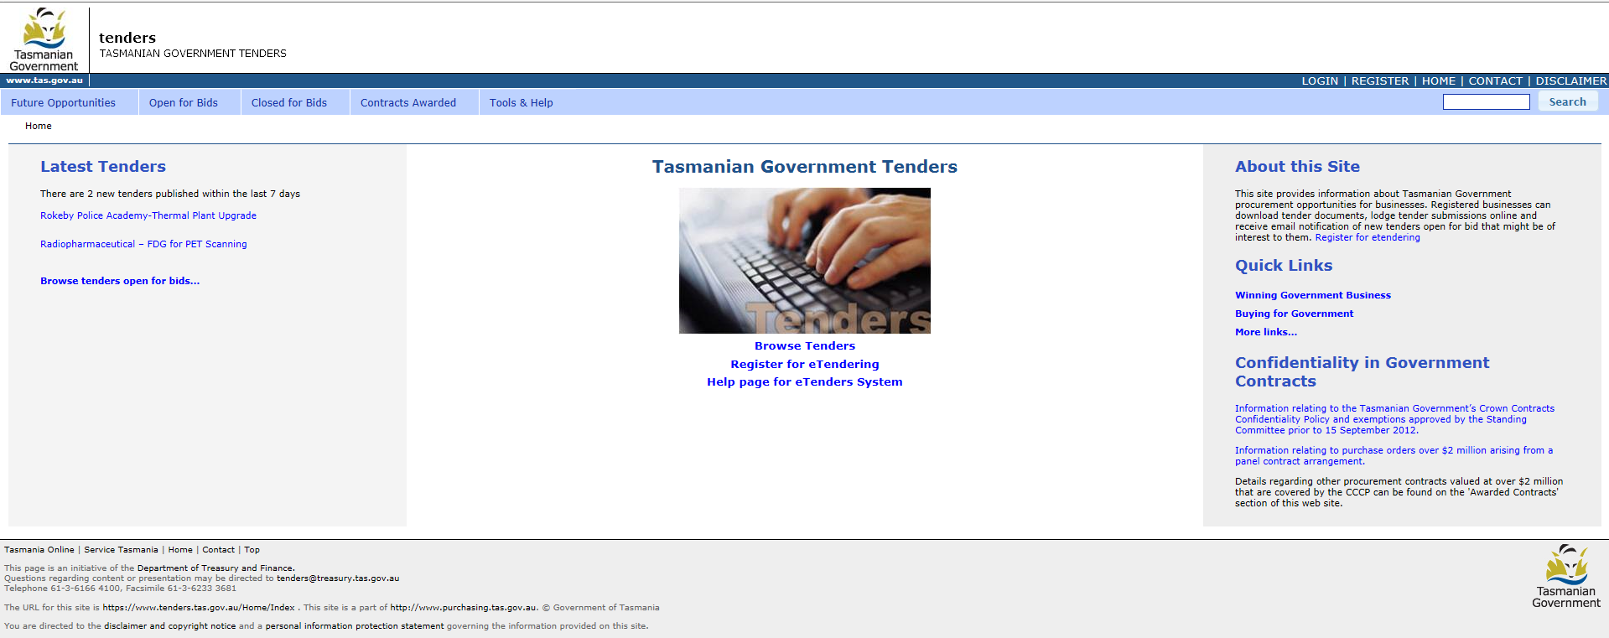
Figure 1. The Tasmanian Government Tenders Home Page

Some tips about using our site
- Avoid using your browser's Back and Forward buttons while using the website. Doing so may cause error messages or interrupt the task you are completing.
- Do not use bookmarks or saved links to specific pages on the website. We recommend using only the links provided in our notification emails.
- For security reasons, your session will automatically time out after 1 hour of inactivity. If this happens while preparing a submission, you may need to start the process again from the home page or continue using a draft submission saved by the system– refer to Incomplete submission further below.
- A demonstration tender is available under Open for Bids. We strongly recommend that you make use of this opportunity to practice so that you are familiar with the process and the details of your account before having to use them in a real situation.
- Do not leave your submission until the last minute. Once the tender closing time has passed and the electronic tender box closes, you will no longer be able to submit your response through the website.

Registration
To register for eTendering, visit:
http://www.tenders.tas.gov.au/registration.
You can access this page using the Register for eTendering link on the Home page.

New registration
There are two steps to registering as a new business user.
Step 1 – Create a new account
- At the Registration page, click the Register to Use eTendering link.
- Enter the requested details: username, email address, password and validation text, and click the Register button.
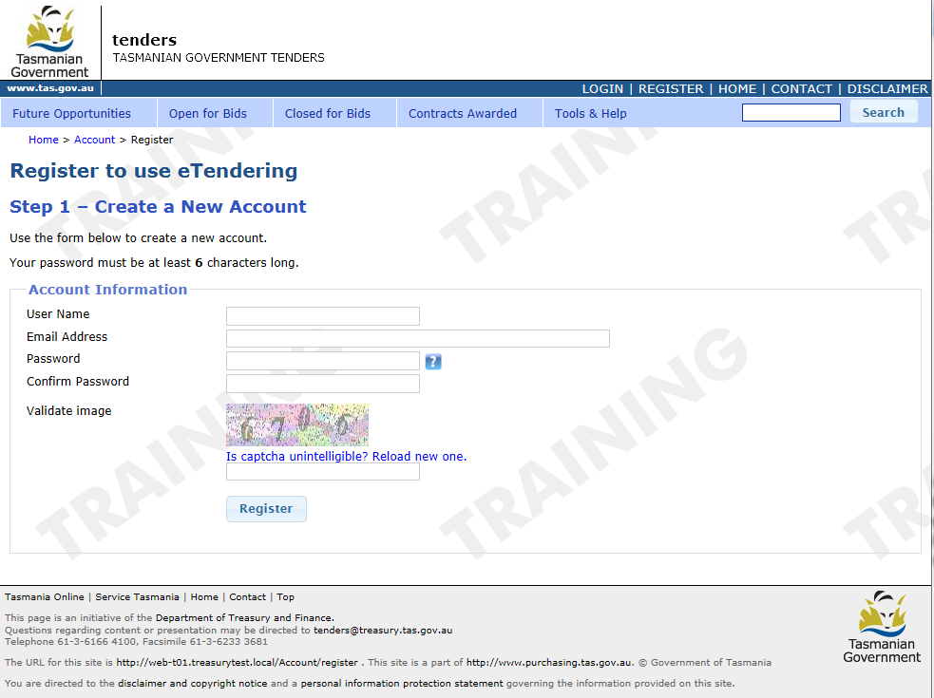
Figure 2. Registration Step 1 – Create a New Account

If the username you select is already in use, you will receive the message: Username is not available.
Passwords must be at least six characters and must include at least one upper case character, one lower case character and one numeric character.
After submitting your registration details, you will receive an eTendering Confirmation Request email, usually within a few minutes. This email will be sent to the email address you provided during registration and contains a link to complete the next step.
Step 2 – Complete account details
- Click on the link provided in the eTendering Confirmation Request email and enter the remaining details to complete your business user account.
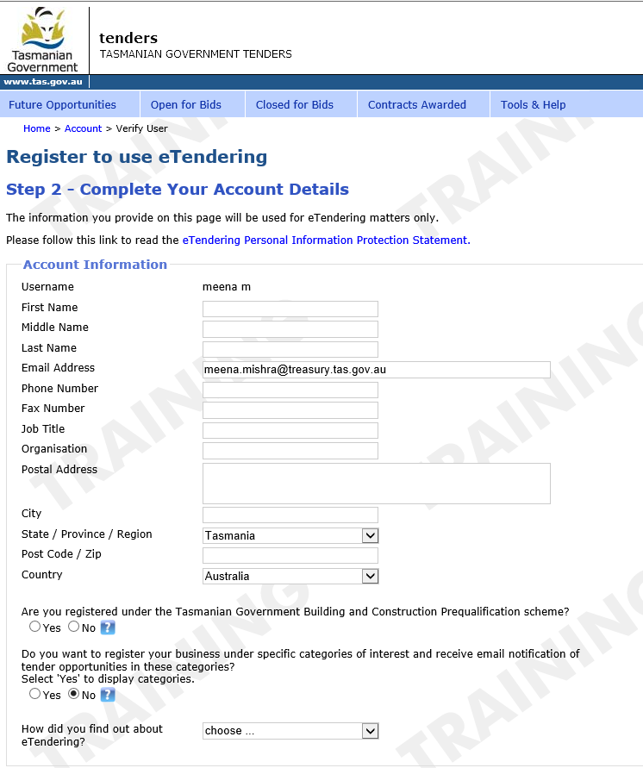
Figure 3. Registration Step 2 – Complete Your Account Details
As a registered user, you can choose to receive email notifications about tender opportunities that may be relevant to your business.
To subscribe to notifications:
- During registration, select Yes when asked: “Do you want to register your business under specific categories of interest and receive email notification of tender opportunities in these categories?”
- A list of categories will be displayed.
- Select the categories that match your business interests.
- You will then receive email notifications when new tenders or future opportunities are published in those categories. This usually occurs on Saturdays.
You can update your categories of interest at any time by logging in to your account and changing your profile settings.
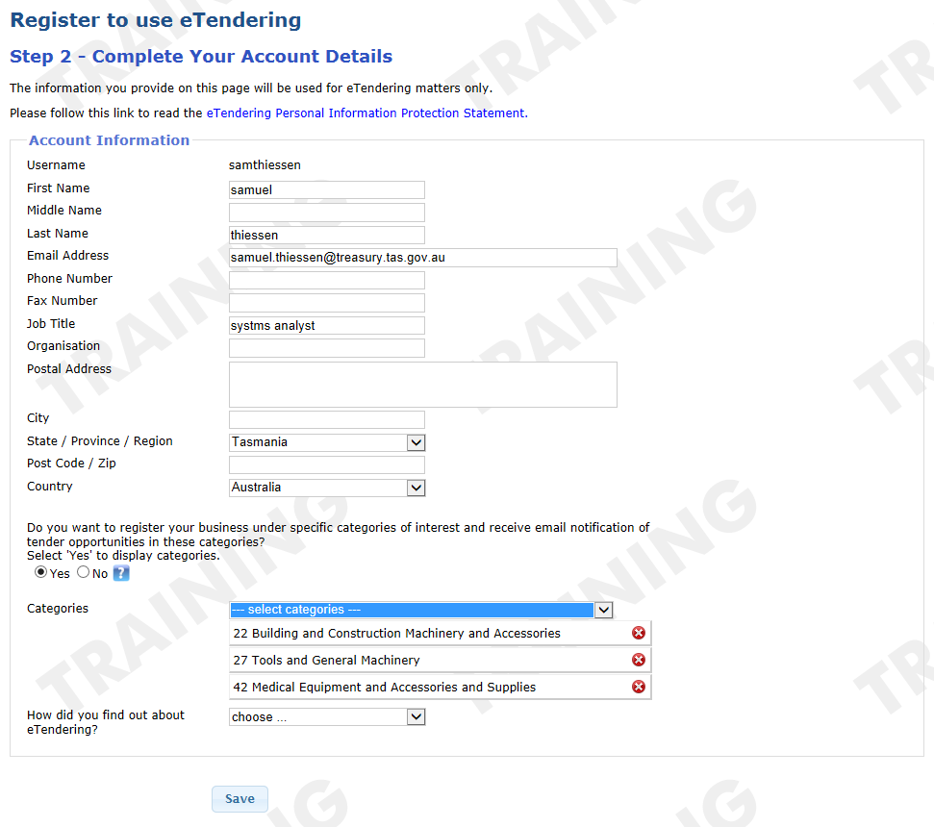
Figure 4. Selecting categories of interest

When you click the Save button you will automatically be logged into the system and will also be sent an email confirming your registration.
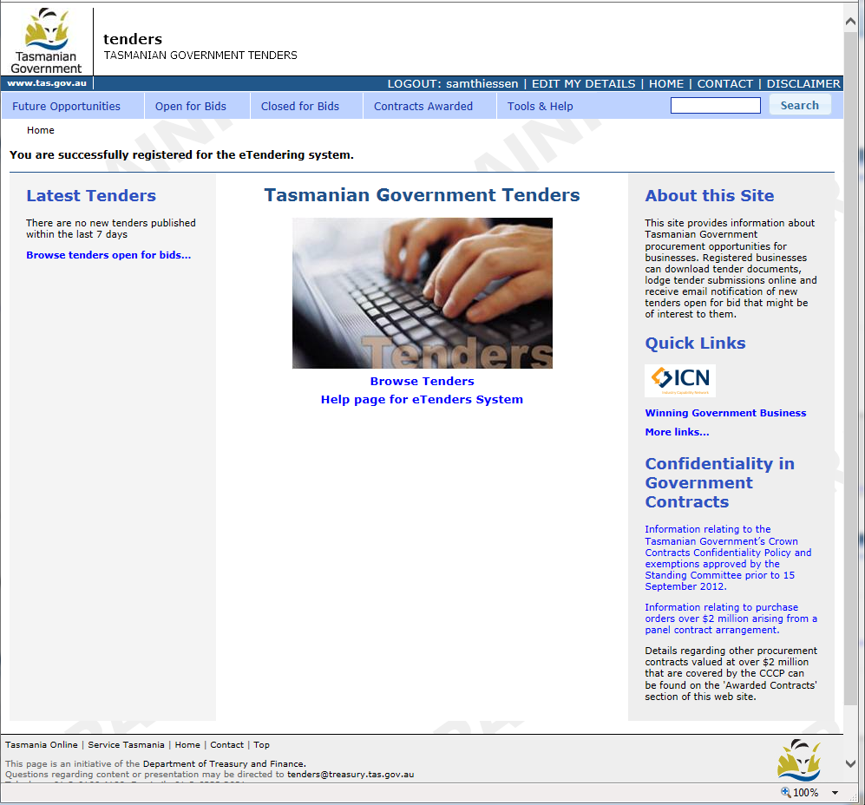
Figure 5. The Registration Confirmation message.

Logging in
You do not need to log in to browse notices. You will be prompted for your login details when you download procurement documents or lodge a submission. To log in otherwise, click the LOGIN link on the Home Page tool bar ribbon.
Enter your username and password and click the Login button.

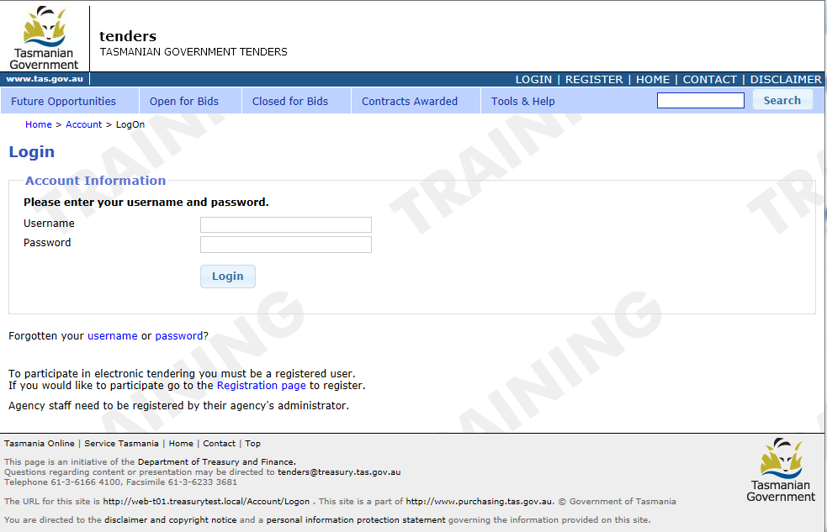
Figure 6. The Login page and the Login link

Forgotten your password?
To retrieve a lost or forgotten password, click password in the Forgotten your username or password? question on the Login page. A form opens requesting your Username.
Click the Email New Password button. An email will be sent to the registered email address for the username, providing a system generated password. Log in to the account using this password and create a new password.

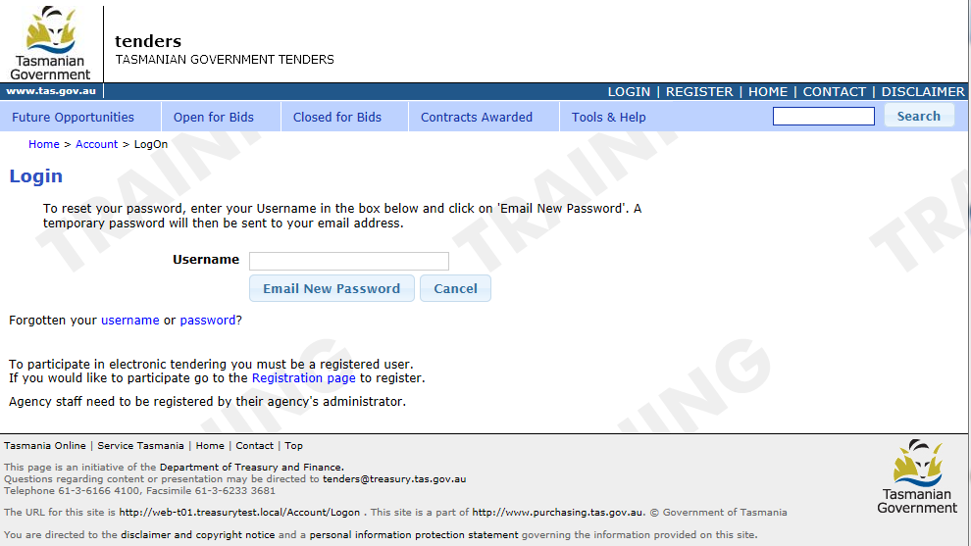
Figure 7. The Forgotten Password Request page
If you have also forgotten your username, you will need to retrieve it before attempting to retrieve your password.
If you have not received the new password email it could be because the username provided to generate the email is incorrect. In that instance you need to first ensure you have provided the correct username. See below for more information.

Forgotten your username?
Click username in the Forgotten your username or password? question on the Login page.
A form opens requesting your Email address.
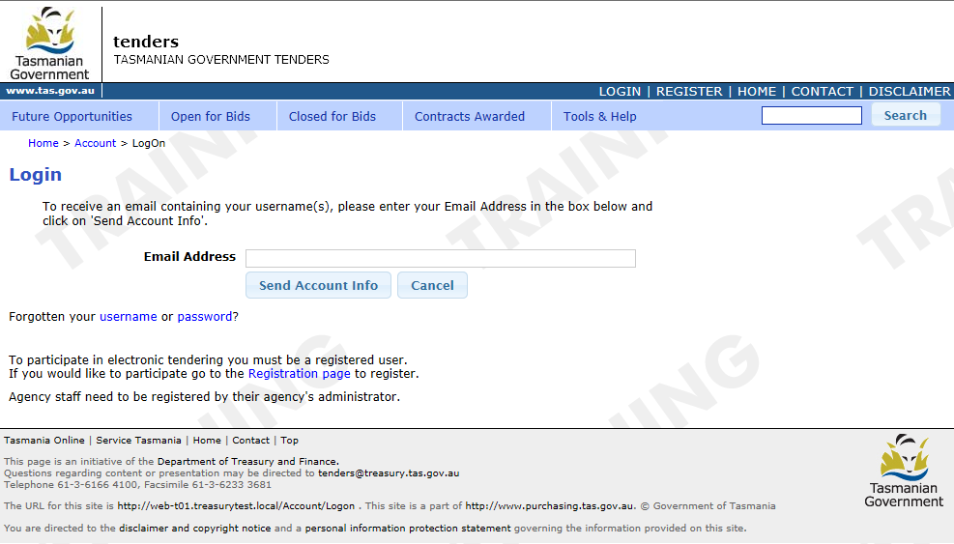
Figure 8. The Forgotten Username Request page
Enter the email address you provided when you first registered on the website. Click the Send Account Info button. Your username will be emailed to you.

Update your registration
- When you need to update your registration details, log in and click the EDIT MY DETAILS link on the Home Page tool bar ribbon. Your registration details will be displayed.
- To make changes to your details:
  - highlight the details of a field that already contains text and type over it to change it; OR
  - click into a blank field and enter the new details.
To change your password, type your new password into both password fields.
Please note that your username cannot be changed.
- To save your modifications and/or additions, click the Save button at the bottom of the form. Click the Close button if you do not want to save changes.
- After saving changes, you will receive a confirmation message on the screen and an email will also be sent to you with your new details. Passwords are not included in emails.

Removing your registration
- You may remove your registration at any time via the EDIT MY DETAILS link on the Home Page tool bar ribbon. Your registration details will be displayed.
- To remove your account simply click on the Remove my Registration button located at the bottom of the page.
- Once removed, you will no longer receive notifications or be able to use the elodgement facility and download functions of the website. You may recreate your account at any time in the future.

Downloadable procurement documentation
If a notice has downloadable files available, the Download Files link will appear at the top of the notice, as shown below.
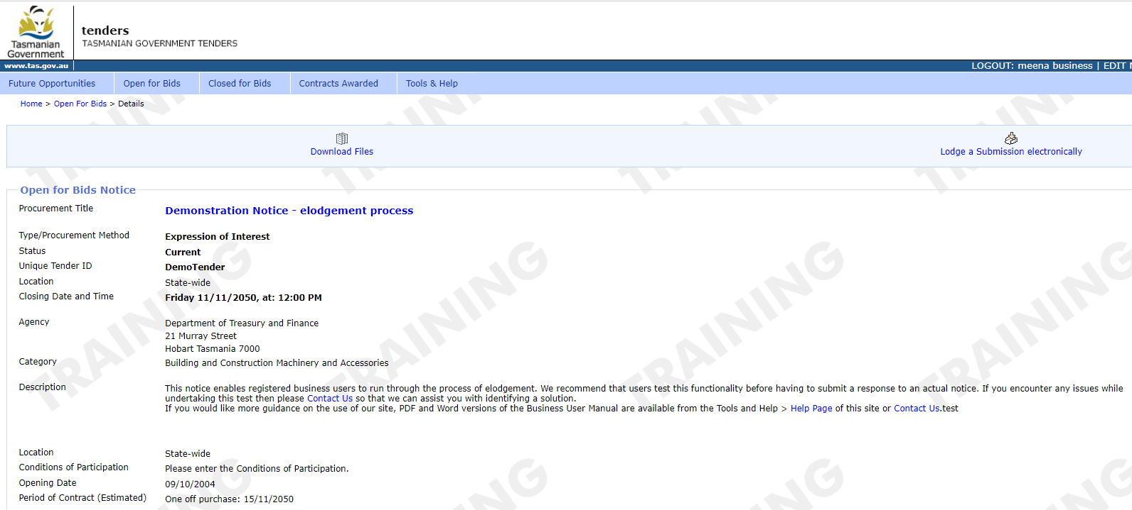
Figure 9. The Procurement Details page – The Download Files link

- To download files, click the Download Files link.
You will be asked to log in with your username and password (if you have not done so already).
Once you are logged in, the Downloadable Documents page will appear (as shown in Figure 10 below).
- To view a file in your internet browser, left click on its link.
- To save the document to your hard drive, click directly on the link and follow the prompts or alternatively on a PC right-click on the link, or on a Macintosh press cmd-click.
- Choose Save Target As…. Now you can choose where to save the file when it has been downloaded. To return to the tender’s detail page, click on the Close button.
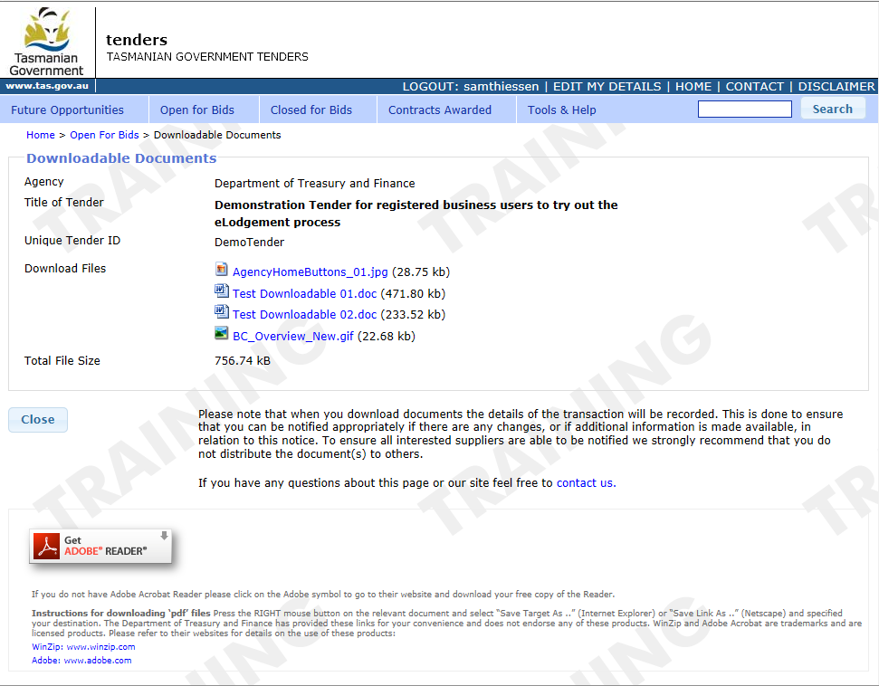
Figure 10. The Downloadable Documents page

Electronic lodgement of submission
The benefits of electronic lodgment include:
- a fast and secure lodgement service;
- 24-hour access to lodge a submission; and
- reduced overheads (eg printing and courier charges).

Important information

Document requirements
When lodging your submission documentation, you may also lodge additional information that will enable the agency to fully assess your submission.
It is advisable that you keep your response to text only or minimise the transmission of images, drawings and brochures, etc, unless information in those formats has been specifically requested.

File Naming Conventions
All electronically lodged files must comply with the following naming conventions:
- File titles must be in English.
- File titles may contain only standard letters and numbers.
- Spaces, underscores (_) and hyphens (-) are permitted.
- No other special characters should be used.
- File names should include the tender number, document name and business name.
Example:
A123_Response_Submission_ABC_Company.docx

Accepted File Types
The following file types are permitted:
- PDF (.pdf)
- ZIP (.zip, .zipx)
- Microsoft Word (.doc, .docx)
- Microsoft Excel (.xls, .xlsx)
- Microsoft PowerPoint (.pptx)
- Image Files (.jpg, .jpeg, .png, .tif, .tiff, .gif)
- Text Files (.txt, .rtf)
- AutoCAD Drawings (.dwg)
It is recommended that you compress your file/s into a zip format. This format will reduce your file size, compress multiple files into a single file, and allow you to upload your response quicker.

File Size Limits
- Individual files must not exceed 100 MB.
- The combined size of all uploaded files must not exceed 500 MB.

Alternative offer
If you have an alternative offer to submit, please ensure that the electronically lodged document has the words ‘Alternative Offer’ in the file name. Please note that the alternative offer that is submitted must also comply with the document naming conventions listed above.

Estimated time for electronic submission
Transmission time on average for a submission can take between 30 seconds and 5 minutes. We strongly recommend that when making a submission through our site you do not leave the submission until the last minute. Once the electronic tender box closes, the website cannot be used to lodge a submission.

How to electronically lodge your Submission
If a notice has electronic lodgement available, then the Lodge a Submission electronically link will appear at the top of the tender, as shown in Figure 11 below.
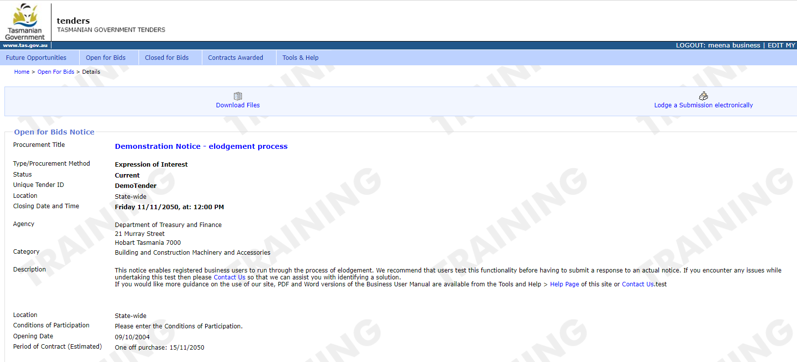
Figure 11. Procurement Details page – Lodge a Submission electronically link

When you click the Lodge a Submission Electronically link, you will be asked to log in with your username and password, if you have not logged in already.

Conditions of use
Once you have logged in, the Conditions of Use page is opened, as shown in Figure 12 below.
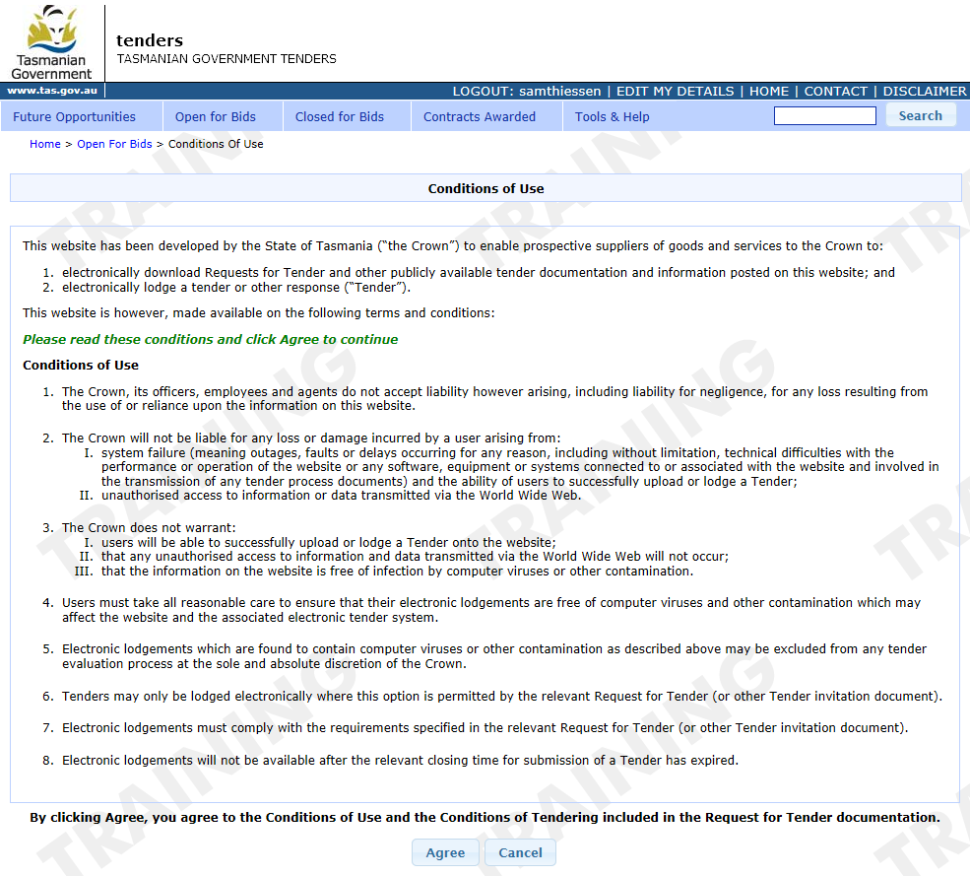
Figure 12. The Conditions of Use page

You should read the conditions of use before continuing.
By clicking on the Agree button, you agree to the Conditions of Use and the eLodgement form is opened. However, if you do not agree, click the Cancel button to go back to the tender’s detail page.

Current time
The Current Date and Time displayed on the tender page helps you check how much time remains before the tender closes.
Please note that the official closing time is determined by the Tasmanian Government eTendering system, not by the clock on your computer or device. The eTendering system operates using Tasmanian Eastern Standard Time (AEST/AEDT).
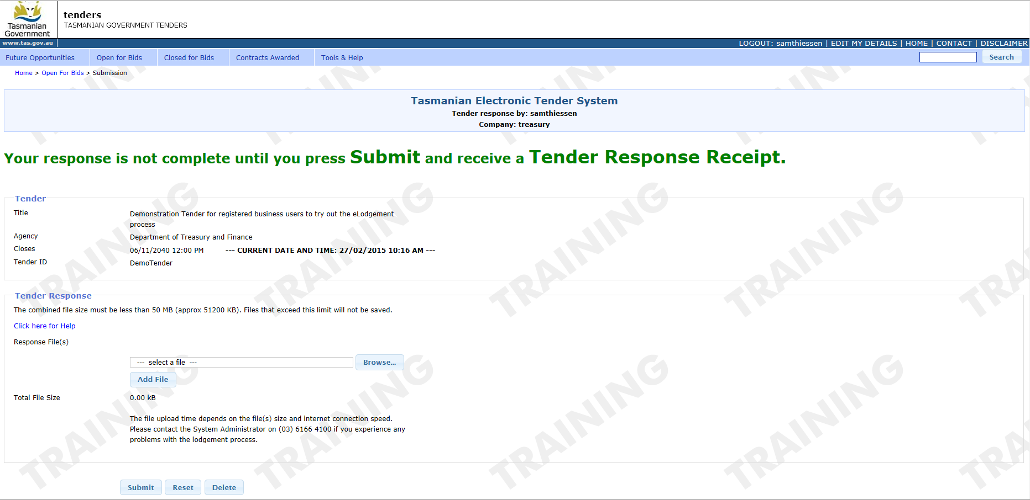
Figure 13. The eLodgement Form

- To begin uploading your files, click the +Add files button and locate the file that you wish to electronically submit.
The address or location of the file you identify will be displayed in the Browse control.
- Click the Open button to upload the selected file.
The file name will appear in the Response Files list immediately above the Browse control. The time this takes depends upon the file size and your internet speed.
- Repeat this process until all the files you wish to submit have been added to the Response Files list.
If a file that you attach is incorrect, you can remove it by clicking the red Delete icon to the right of the file name. Alternatively, you can use the Reset button to remove all the files or select the Delete Submission button at the bottom of the page to remove the entire submission from the eTendering system.
- Alternatively, you could drag and drop the files you wish to submit into the box above the +Add files button.
- Once you have attached all the files, click the Submit button.

Submission confirmation
When the Tasmanian Government eLodgement system receives your electronically lodged response, you will be presented with a Receipt of Submission as confirmation. This confirmation will also be emailed to you.
Your submission is not complete until you have clicked on the Submit button and received a receipt of submission. If you do not receive a receipt for the submission, contact the system administrator. You can only delete submissions that have not been submitted to the electronic tender box, any submission for which you have received a receipt of tender response cannot be deleted.

Incomplete submission
During the submission process, the system automatically saves your response as a draft until it is successfully submitted to the electronic tender box or deleted.
A submission will not be received if you do not select the Submit button. It may also remain incomplete if there is a system issue or an interruption to your internet connection.
Any submission that has not been successfully submitted by the tender closing time will be automatically deleted and cannot be recovered.

Amending or adding files
If you need to amend or add any files after submitting, you can send a replacement file or additional file by following the steps for uploading and submitting your files. But this time you should include the word ‘addendum’ or ‘addition’ in the document’s name. For example:
A123_Addendum_Response_Submission_ABC_Company.doc
You will receive another receipt to acknowledge your new submission.

How to submit a response to a selective tender (Multi-Stage procurements)
Some procurements are conducted in multiple stages. In these cases, the first stage may be advertised as an Expression of Interest (EOI) or Request for Proposal (RFP).
Based on the responses received in stage one, the agency may shortlist suppliers to participate in stage two.
Stage two procurement documents are not published publicly on the Tenders website. Instead, shortlisted suppliers receive an email invitation containing a link to:
- access the stage two procurement documents; and
- submit an electronic response.
This email is unique to the shortlisted supplier and cannot be used by other users to access the procurement. You should keep the stage two notification email, as you will need it to access the tender notice and lodge your response.
If you submitted a response to stage one and have changed your email address since then, contact the agency enquiry officer listed in the procurement notice to update your details and request that the stage two notification email be reissued.

How to submit an application for the Technology Services Multi-Use List (TSL)
The TSL is a multi-use list, used by government agencies to conduct their own technology services procurements. From 16 August 2021, only listed suppliers will be invited to participate in TSL procurements.
You can apply for inclusion on the TSL at any time. You will need to be registered on the Tenders Website as a business user to be able to submit an application and to be added to the TSL. If you are already registered, please ensure your login details and other personal information are correct. If you need assistance to retrieve or amend your login details, please contact the Systems Administrator at tenders@treasury.tas.gov.au
The application package can be accessed from the TSL Open for Bids notice on the Tenders website. Completed applications must be submitted using the eLodgement facility available on the Technology Services Multi-Use List notice page.
For instructions on submitting an application online, refer to the How to Electronically Lodge Your Submission section of this guide. Your application will then be assessed, and the outcome will be emailed to the contact person nominated in your application.
Once you have been added to the TSL, details about your organisation will be available to agency users.
It is important that the TSL contains current supplier contact information, to ensure that agencies can notify suppliers of TSL procurement opportunities. If the details of the contact nominated in your application change, please ensure that these are updated on the contact’s eTenders account. If you have a new contact, please advise the TSL administration team via email (tsl@treasury.tas.gov.au).

Invitation to participate in a TSL procurement
When an agency conducts a TSL quotation or tender process, it invites TSL suppliers to participate via the Tenders website, either through selecting individual suppliers (only available for TSL quotations) or selecting groups of suppliers via TSL categories.
If an agency invites you to participate in a TSL procurement process, you will receive an email from the Tenders website containing a link to the procurement notice and downloadable documents. You will need to be logged in to your Tenders website account to view these (they are not openly published on the website). The notice will be available in your Open for Bids list. Please note that the email link will not allow other business users to log in to the website.
Only suppliers who have been invited to participate can submit a response to the TSL quotation or tender. Submissions must be made using the eLodgement facility.

Need more help?
If you need help with the Tenders Website, please contact the Procurement and Systems Administrator from the Procurement Risk and Contract Management Branch, Department of Treasury and Finance, on (03) 6145 5888 or email tenders@treasury.tas.gov.au

Useful Links
- 1-page Bidding for Government Contracts Fact Sheet
- Tasmanian Government Supplier Code of Conduct
- Tasmanian Government Supplier Code of Conduct: Fact Sheet
- Tendering Handbook: a guide to tendering or quoting for Tasmanian Government business
- Tenders Website fact sheet

Quick Links
- Winning Government Business
- Buying for Government

